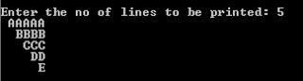

Answer

var n=prompt("Enter a number");

for(i=1;i<=n;i++)

{

for(j=1;j<i;j++)

{

document.write("&nbsp&nbsp");

}

for(j=n;j>=i;j--)

{

document.write(String.fromCharCode(64+i));

}

document.write("<br>");

}

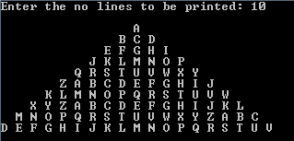

Answer

var n=prompt("Enter a number");

var count=0;

for(i=1;i<=n;i++)

{

for(j=n;j>=i;j--)

{

document.write("&nbsp&nbsp");

}

for(k=1;k<=2*i-1;k++)

{

if(count==26)

{

count=0;

}

document.write(String.fromCharCode(65+count));

count++;

}

document.write("<br>");

}

**3)  Draw the following Pattern**

A  
B A B  
C B A B C  
B A B  
A

Answer

var n=prompt("Enter a number");

for(i=0;i<n;i++)

{

for(j=0;j<=i*2;j++)

{

document.write(String.fromCharCode(65+(Math.abs((i-j)))));

}

document.write("<br>");

}

for(i=n-2;i>=0;i--)

{

for(j=0;j<=i*2;j++)

{

document.write(String.fromCharCode(65+(Math.abs((i-j)))));

}

document.write("<br>");

}

**4.Given string str, How do you find the longest palindromic substring in str?**

**For example, the longest palindromic substring of "bananas" is "anana"**

Answer

function isPalindrom(arr) {

let i = 0;

let j = arr.length - 1;

while (i <= j) {

if (arr[i] !== arr[j])

return false;

i++;

j--;

}

return true;

}

function longestPalindrome(s) {

let len = s.length;

while (len > 0) {

for (let i = 0; i < s.length - len + 1; i++) {

var str = s.slice(i, i + len);

if (isPalindrom(str))

return str;

}

len--;

}

return "";

};

var n = prompt("Enter a string")

document.write(longestPalindrome(n))

**5) How do you print the first non-repeated character from a string**

Answer

var str=prompt("Enter a string");

var flag=0;

for(i=0;i<str.length;i++)

{

for(j=0;j<str.length;j++)

{

if(str[i]==str[j])

{

flag++;

}

}

if(flag==1)

{

document.write(str[i]);

break;

}

flag=0;

}